**Machine Learning on Agriculture Dataset**

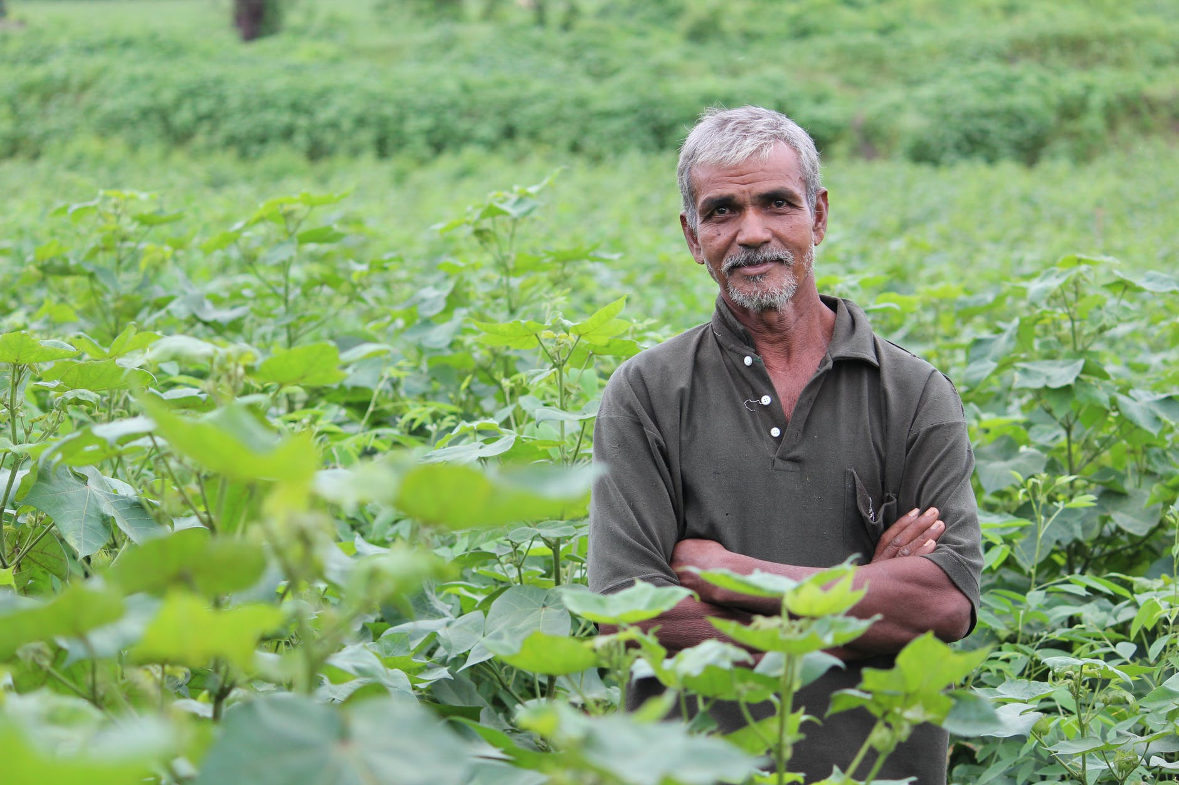

**Date:- 27-Feb-21 Author- Vikas Ojha**

**Problem Definition**

Context:

In the present world, concept of Machine Learning is widely used in all the sectors to determine upcoming instances. One of such field is Agriculture. We can use in all the process of Agriculture from seed selection as per soil type, soil preparation, seed breeding along with water feed management.

Machine Learning Technique emerged as smart way in field of Agriculture for Smart farming that makes agriculture more efficient and effective with its high precision Algorithms.

Content:

The farming task or farmers job is not an easy task. They have to work hard on the agricultural field with high strength and determination. Initially they prepare the land for sowing the seed into it. Once they sow the seed into land, they have to work day and night to make sure that he gets maximum output (Harvest) at the end of season. Availability of water, soil fertility, protecting crops from rodents, timely use of pesticides & other useful chemicals and nature are some important factors that ensure good harvest at the end of season. As all these factors are not possible for a farmer to control but the amount and frequency of pesticide can be controlled.

Pesticides are also very important as they protect the crop from damage. If we use pesticides more than the required, it may damage the entire crop which means dead crop and even can spoil the soil. The data on which we are going to work is based on crops harvested by various farmers at the end of season.

We need to predict the outcome of harvest season, weather the crop would be healthy(alive) or damaged by pesticides or by any other reason.

**Data Analysis**

Before we start the analysis of data, we need to import the supporting libraries such as pandas, numpy, matplotlib, seaborn, etc. These libraries are essentially required to perform task on our dataset.

1. 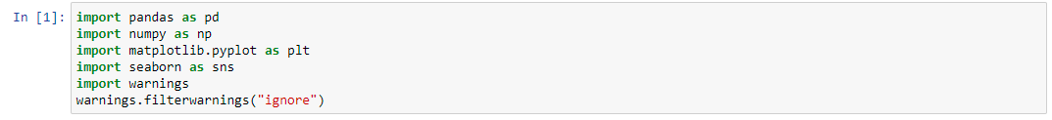*Support Libraries:*
2. 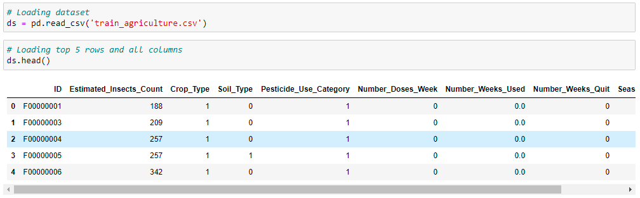*Loading Dataset:*

Now, as we have loaded our dataset, it was found that we have 2 different files for train and test data. Initially we have to work on train data and prepare our model to look which model is giving best accuracy. Then we will save our model in. pkl form.

Then we will load test data and will perform all the tasks as performed on train data. Then we will import our saved model and we will fit the test data into our model to get our result.

Dataset contains 10 columns namely ID, Estimated Insects Count, Crop Type, Soil Type, Pesticide Use Category, Number Doses Week, Number Weeks Used, Number Weeks Quit, Season and Crop Damage

Following are the details of each columns: -

|  |  |  |
| --- | --- | --- |
| ***Sr No.*** | ***Column*** | ***Description*** |
| *1* | **ID** | *Unique Identification Number given to each crop.* |
| *2* | **Estimated Insects Count** | *Estimated Insects Count on the crop*  *(Values between 150 – 4097)* |
| *3* | **Crop Type** | *Category of the Crop*  *(****0*** *- Rabi /* ***1*** *- Kharif)* |
| *4* | **Soil Type** | *Category of the soil in which the crop was grown. (****0*** *-* Alluvial */* ***1*** *- Black-Cotton)* |
| *5* | **Pesticide Use Category** | *Category of the Pesticide Used on the crop*  *(****1*** *- Insecticides /* ***2*** *- Bactericides /* ***3*** *- Herbicides)* |
| *6* | **Number Doses Week** | *Number of Doses given to the crop*  *(Values between 0 – 95)* |
| *7* | **Number Weeks Used** | *Number of Weeks for which the pesticide*  *(Values between 0 – 67)* |
| *8* | **Number Weeks Quit** | *Survival duration of the crops in weeks.*  *(Values between 0 – 50)* |
| *9* | **Season** | *The season in which the crop was grown*  *(****1*** *- Summer/* ***2*** *- Monsoon/* ***3*** *- Winter)* |
| *10* | **Crop Damage** | *Classification of the amount of damage to the crop. (****0*** *- Minimal /* ***1*** *- Partial /* ***2****- Significant Damage)* |

In this project we will use different exploratory data analysis techniques. Before we proceed further, we need to understand more about dataset. Let’s understand the variables to which we are playing with.

Now let’s check the shape of our train data.



We can see that our train dataset contains 88858 rows and 10 columns. Now let’s check on the missing data in our dataset.

1. 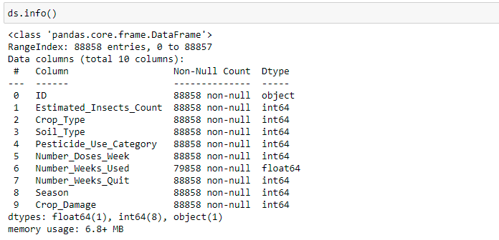*Dataset Types:*

There are 3 different datatypes, namely object, int64 and float64. ID column is of categorical type which we need to convert afterwards using Label Encoder, if needed as machine learning model cannot understand categorical variables.

We will perform the following steps further in this dataset: -

1. Finding missing values in dataset, if any
2. Univariate and Bi Variate Analysis
3. Summary Statistics
4. Correlation Check
5. Skewness check
6. Label Encoding of categorical data
7. Checking and removing outliers, if any
8. Defining x and y variables
9. Removing skewness from x variable
10. Apply standard scaler
11. Apply different Algorithms on model
12. Hyper Parameter tuning using GridsearchCV
13. Saving the best model

**Exploratory Data Analysis**

As discussed above, now we will check the missing data in Dataset.

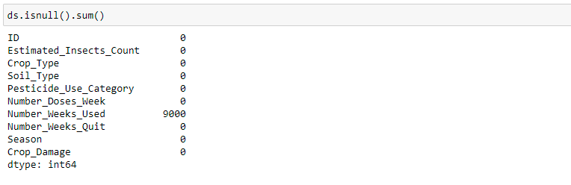

Oh No! Number Weeks Used Column contains 9000 missing data. We need to replace these NaN values with some appropriate data.

**Handling NaN Values**

Now let’s check the unique values in Number_Weeks_Used column.

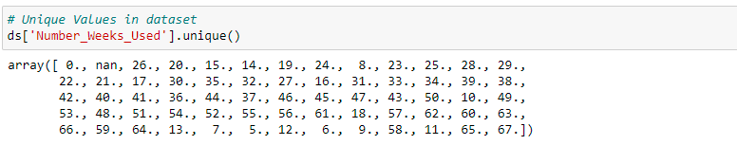

There are two ways to handle this NaN values. First, we can replace the NaN values with the mean of the column or secondly, we can fill the missing values with the number which has highest number of occurrences in the column. It is known as Mode. I choose the Mode method to replace the NaN values as it suits the best in present scenario.



Now we have filled the missing data with mode. Let’s verify whether the missing value have been replaced or not.

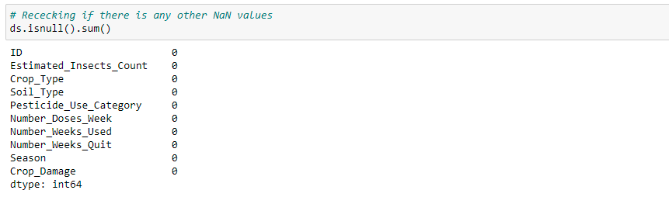

There are no missing values in our dataset now. We can now proceed with further analysing our dataset.

**Summary Statistics**

Let’s draw some observations from summary statistics.

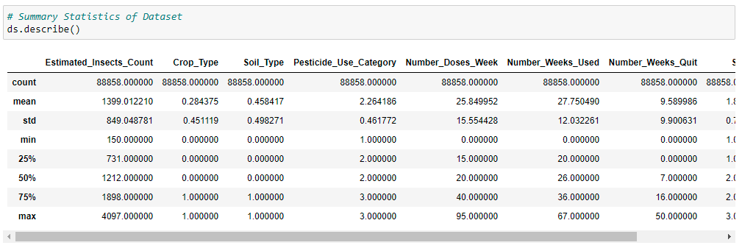

Observations:

1. Few columns are highly skewed.
2. Few columns have outliers present, we will check it later.

Now finding mean, standard deviation, median, minimum and maximum values in our dataset.

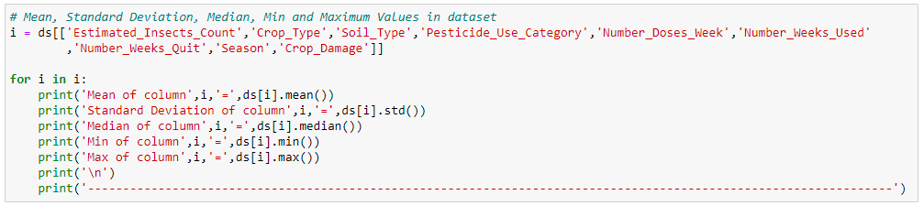

Observations:

Mean of column Estimated_Insects_Count = 1399.0122104931463

Standard Deviation of column Estimated_Insects_Count = 849.0487806670102

Median of column Estimated_Insects_Count = 1212.0

Min of column Estimated_Insects_Count = 150

Max of column Estimated_Insects_Count = 4097

----------------------------------------------------------------------------------------------------------------

Mean of column Crop_Type = 0.2843750703369421

Standard Deviation of column Crop_Type = 0.4511188091517885

Median of column Crop_Type = 0.0

Min of column Crop_Type = 0

Max of column Crop_Type = 1

----------------------------------------------------------------------------------------------------------------

Mean of column Soil_Type = 0.4584167998379437

Standard Deviation of column Soil_Type = 0.4982706408302739

Median of column Soil_Type = 0.0

Min of column Soil_Type = 0

Max of column Soil_Type = 1

----------------------------------------------------------------------------------------------------------------

Mean of column Pesticide_Use_Category = 2.2641855544801817

Standard Deviation of column Pesticide_Use_Category = 0.4617715815834632

Median of column Pesticide_Use_Category = 2.0

Min of column Pesticide_Use_Category = 1

Max of column Pesticide_Use_Category = 3

----------------------------------------------------------------------------------------------------------------

Mean of column Number_Doses_Week = 25.849951608183844

Standard Deviation of column Number_Doses_Week = 15.55442776539594

Median of column Number_Doses_Week = 20.0

Min of column Number_Doses_Week = 0

Max of column Number_Doses_Week = 95

----------------------------------------------------------------------------------------------------------------

Mean of column Number_Weeks_Used = 27.750489545116928

Standard Deviation of column Number_Weeks_Used = 12.032260928714667

Median of column Number_Weeks_Used = 26.0

Min of column Number_Weeks_Used = 0.0

Max of column Number_Weeks_Used = 67.0

----------------------------------------------------------------------------------------------------------------

Mean of column Number_Weeks_Quit = 9.589986270228904

Standard Deviation of column Number_Weeks_Quit = 9.900631115270183

Median of column Number_Weeks_Quit = 7.0

Min of column Number_Weeks_Quit = 0

Max of column Number_Weeks_Quit = 50

----------------------------------------------------------------------------------------------------------------

Mean of column Season = 1.8969591933196785

Standard Deviation of column Season = 0.7013221327434505

Median of column Season = 2.0

Min of column Season = 1

Max of column Season = 3

----------------------------------------------------------------------------------------------------------------

Mean of column Crop_Damage = 0.19056247045848432

Standard Deviation of column Crop_Damage = 0.4542150681956372

Median of column Crop_Damage = 0.0

Min of column Crop_Damage = 0

Max of column Crop_Damage = 2

We will have a look in the unique values in all the columns.

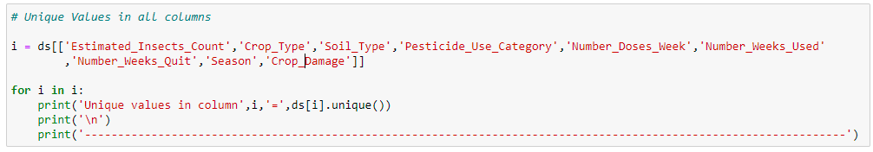

Observations:

Unique values in column Estimated_Insects_Count = [ 188 209 257 342 448 577 731 1132 1212 1575 1785 2138 2401 2999 3516 3895 4096 150 151 168 232 231 256 283 312 311 375 411 410 488 489 531 626 625 677 732 789 790 851 850 915 916 984 1056 1296 1297 1385 1478 1576 1678 1786 1898 2015 2016 2139 2267 2402 2542 2541 2688 2687 2840 3164 3165 3336 3337 3702 3896 169 3515 4097]

----------------------------------------------------------------------------------------------------------------

Unique values in column Crop_Type = [1 0]

----------------------------------------------------------------------------------------------------------------

Unique values in column Soil_Type = [0 1]

----------------------------------------------------------------------------------------------------------------

Unique values in column Pesticide_Use_Category = [1 3 2]

----------------------------------------------------------------------------------------------------------------

Unique values in column Number_Doses_Week = [ 0 30 40 60 20 25 45 50 15 10 5 35 70 55 80 90 85 65 75 95]

----------------------------------------------------------------------------------------------------------------

Unique values in column Number_Weeks_Used = [ 0. 20. 26. 15. 14. 19. 24. 8. 23. 25. 28. 29. 22. 21. 17. 30. 35. 32. 27. 16. 31. 33. 34. 39. 38. 42. 40. 41. 36. 44. 37. 46. 45. 47. 43. 50. 10. 49. 53. 48. 51. 54. 52. 55. 56. 61. 18. 57. 62. 60. 63. 66. 59. 64. 13. 7. 5. 12. 6. 9. 58. 11. 65. 67.]

----------------------------------------------------------------------------------------------------------------

Unique values in column Number_Weeks_Quit = [ 0 1 9 4 13 3 14 6 2 12 15 10 8 11 7 5 17 18 16 20 21 19 22 24 23 27 25 28 26 29 30 31 33 32 36 37 34 39 44 41 35 47 46 40 42 38 43 45 49 50 48]

----------------------------------------------------------------------------------------------------------------

Unique values in column Season = [1 2 3]

----------------------------------------------------------------------------------------------------------------

Unique values in column Crop_Damage = [0 1 2]

We have seen all the unique values in all the columns.

**Univariate Analysis**

## We will now plot the countplot of all the columns of draw some useful insights from dataset .

Estimated Insects Count

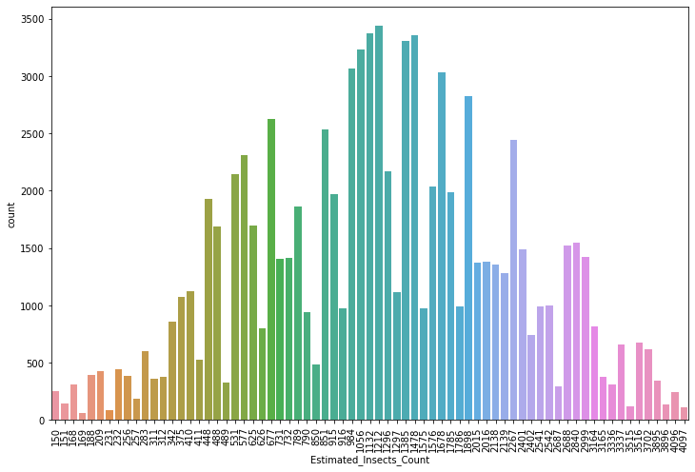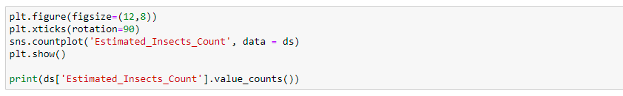

Observations:

Following are the top 5 insects counts.

1212 - 3438

1132 - 3370

1478 - 3358

1385 - 3309

1056 - 3235

Crop Type

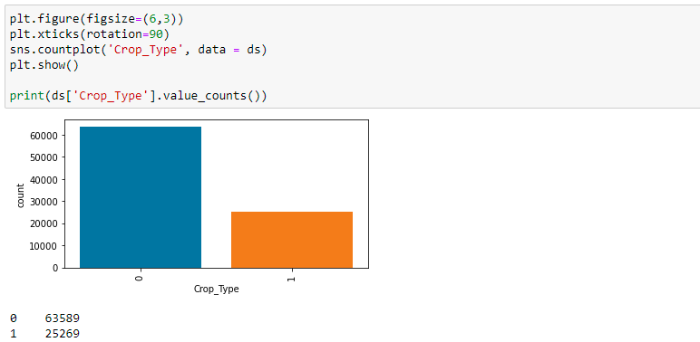

Observations:

1. 0 is Rabi crop and 1 is Kharif Crop
2. Rabi crop has the maximum number of instances. As per dataset 71.5 % data are Rabi Crop
3. Rest are Kharif Crop.

Soil Type

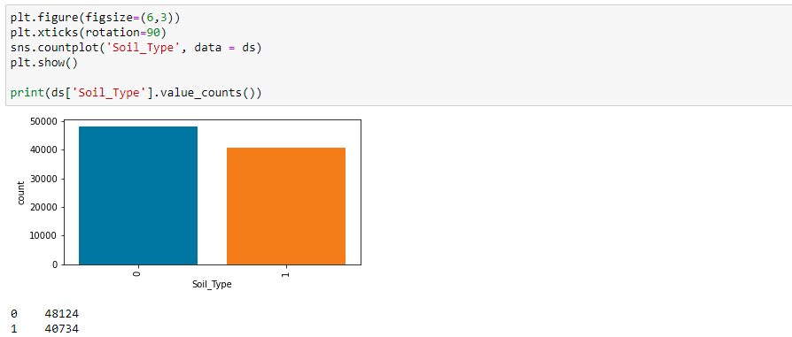

Observations:

1. 0 is Alluvial Soil and 1 is Black Cotton Soil.
2. As per dataset 54% of Soil is Alluvial.

Pesticide Use

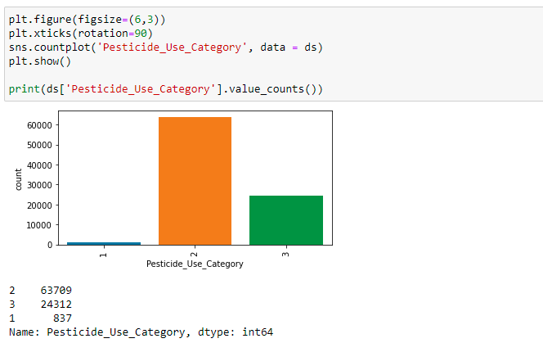

Observations:

1. 1 – Insecticides, 2 – Bactericides and 3 – Herbicides
2. From plot we can say that Bactericides are mostly used on all types of Crops.
3. Insecticides are very often used.

Number Doses Week

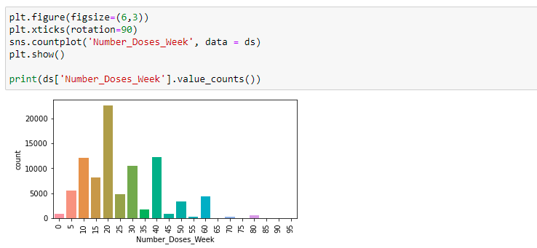

Observations:

1. Maximum 20 doses are given on crop of approx. 22000 instances.
2. Minimum is Zero.

Season

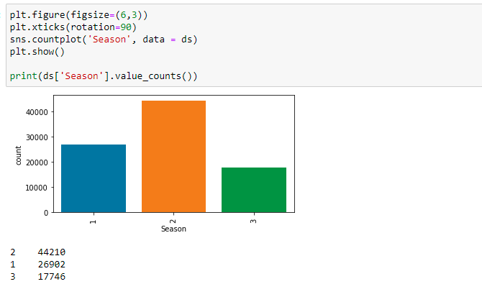

Observations:

1. There are three types of seasons in dataset namely Summer, Winter and Monsoon
2. Here 1 is Summer, 2 is Monsson and 3 is Winter
3. Monsoon instances are higher as compared to other seasons. It is ~ 50% in terms of instances.
4. Second most preferred season is Summer.

Crop Damage

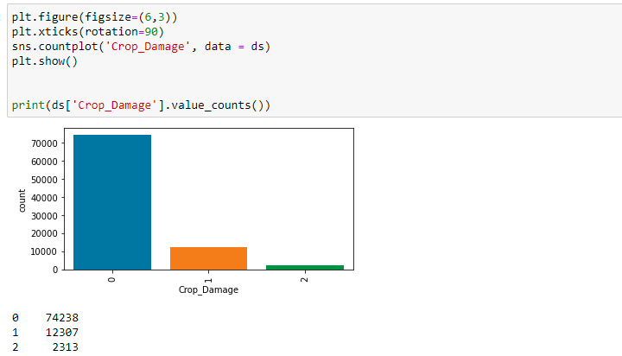

Observations:

1. There are three reasons for crop damage namely Minimal Damage, Partial Damage and Significant damage.
2. Here 0 is Minimal Damage, 1 is Partial Damage and 2 is Significant damage.
3. The instances od Minimal damage is more which comprises of ~84%.

**Bivariate Analysis with Target Variable.**

Crop Damage-Estimated Insects Count

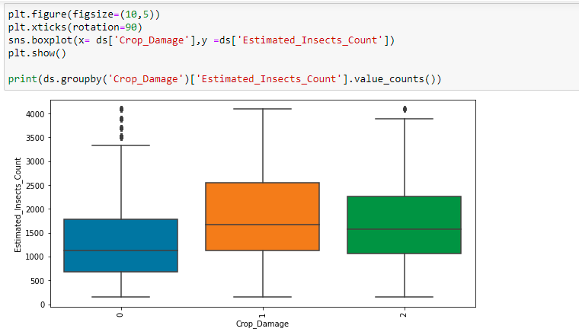

Observations:

Crop Damage – Number Doses Week

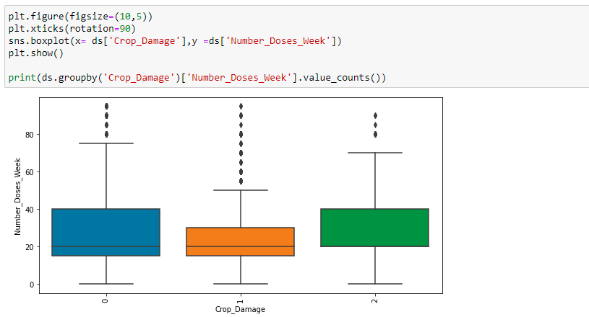

Observations:

Crop Damage – Number Week Used

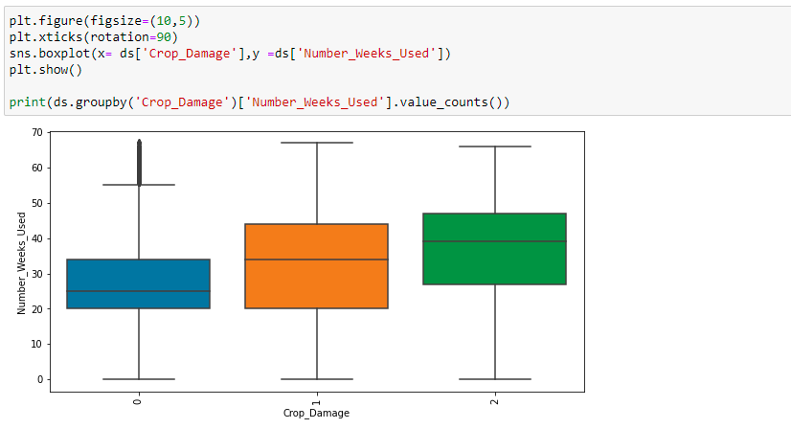

Observations:

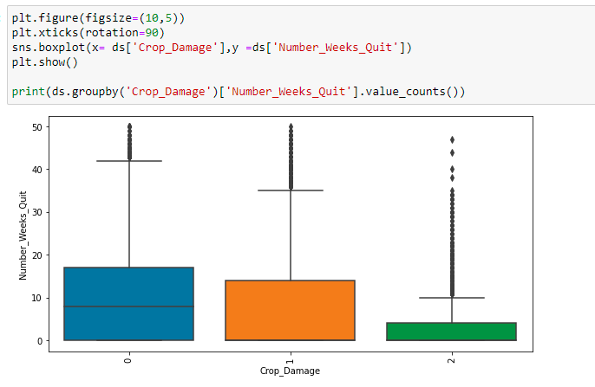Crop Damage – Number Week Quit

Observations:

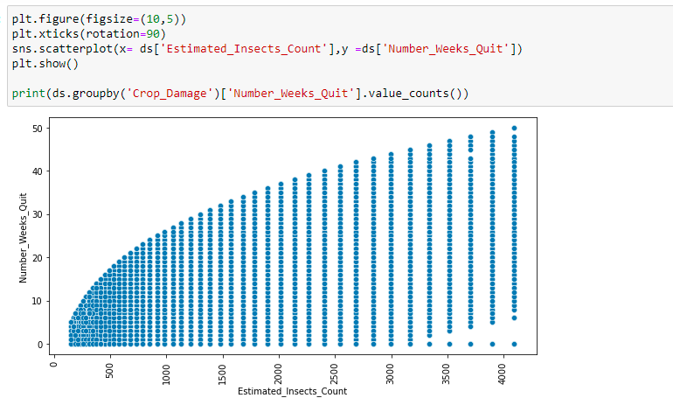Estimated Insects Count-Number Weeks Quit

Observations:

Number Weeks Used – Number Weeks Quit

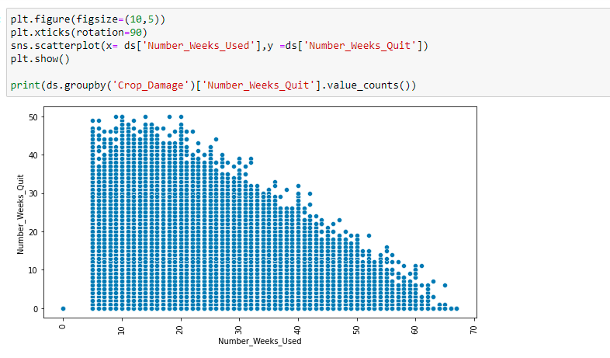

Observations:

**Correlation Heatmap**

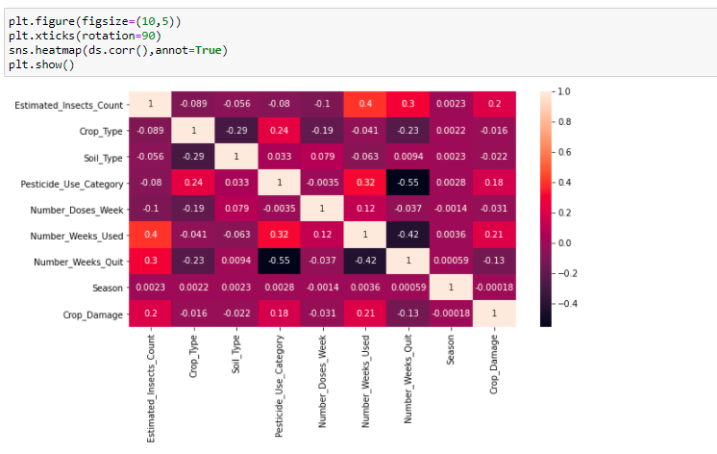

Observations: